**Farm-to-Table Recognition Programme (FTTRP)**

**Logo Application Form**

**About the Farm-to-Table Recognition (FTTRP) Logo**

1. The FTTRP Logo is an award recognition given to food businesses that procure at least 15% of local produce in any of the 6 food categories, i.e. Hen Shell Eggs, Leafy Vegetables, Beansprouts, Fish, Mushrooms and Quail Eggs.
2. The award recognition is valid for 2 years from the date of approval for the logo usage. Food businesses will need to submit a new FTTRP application for renewal thereafter.
3. This is a tiered award system (3 tiers), where a higher tier will be awarded to food businesses that achieve at least 15% of local produce procurement in more food categories:
   * **Base Tier** – to achieve **at least 1** food category
   * **Mid Tier** – to achieve **at least 2** food categories
   * **Highest Tier** – to achieve **at least 3 or more** food categories
4. The application will be assessed by dollar value, i.e.

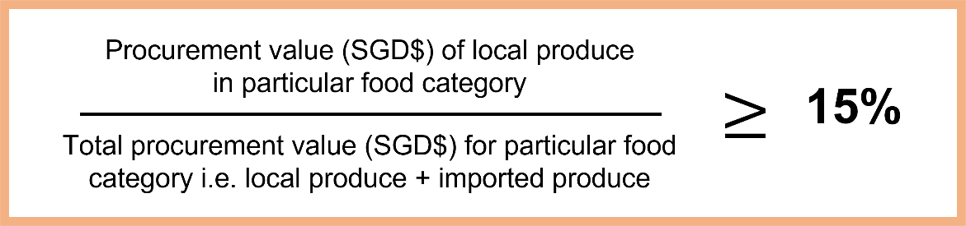

1. Successful applicants will be subject to random audits during the period of logo validity.

**Submission through FormSG link**

1. Submission that is incomplete or ineligible will not be considered.
2. Submission must be made through the link: <https://go.gov.sg/fttapplication>
3. Documents should be submitted in a **single zip folder** through the FormSG link. Please name the folder **[Company Name_UEN Number]**

**Section 1: Applicant’s Details**

|  |  |
| --- | --- |
| **Company Details** | |
| Company Name: |  |
| Company Address: |  |
| UEN Number: |  |
| Business Description: | e.g. Chinese restaurant offering dim sum and seafood selection |
| Type of Company:  *Please only tick 1* | Parent Company  Subsidiary Company |
| List all subsidiary companies or business brands included in the application:  *This applies to applications submitted by a parent company on behalf of its subsidiaries or business brands* |  |
| **SFA Licence Details**  *for each food establishment that is included in the application*  *For more than 1 licence, you may provide the information in an excel file indicating the following:*  *Licensee Name, Licence Number, Licence Type, Licence Validity Period, Address of Food Establishment(s) and Food Establishment Business Name* | |
| Licensee Name: |  |
| Licence Number: |  |
| Licence Type:  *You may tick more than 1* | Food Shop Licence  Food Stall Licence  Food Manufacturing Licence |
| Licence Validity Period:  *DD MM YYYY to DD MM YYYY* | e.g. 3 Nov 2022 to 2 Nov 2023 |
| Address of Food Establishment(s)  *(as reflected in the SFA licence issued)* |  |
| Food Establishment Business Name |  |

**Section 2: Submission Details and Supporting Documents**

|  |  |
| --- | --- |
| Number of Food Categories Meeting at least 15% of Local Produce:  *Please only tick 1* | 1 Category  2 Categories  3 or More Categories |
| Food Category (Type of Local Produce):  *You may tick more than 1.*  *Please ensure that it corresponds to the number of food categories* | Hen Shell Eggs  Leafy Vegetables  Beansprouts  Fish  Mushrooms  Quail Eggs |
| Procurement Records  To submit **1 month’s worth** of procurement records within the last 6 months at point of application, documents to include:   1. Invoices of Local Produce and Imported Produce (in Zip folder) 2. Summary of Procurement (in Excel sheet) *– use the excel template downloadable on SFA’s website* | Please provide the procurement records inside your zip folder  **To note**  Naming Format for Each Invoice:  Invoice Number_YYYYMMDD  Local produce invoice must contain the name and location (farm address) of the local farm  Imported produce invoice must contain the name of importer and country of origin of produce  Produce name must be clear, e.g. Xiao Bai Cai |
| Intended Use of the FTTRP Logo  *Provide examples of where the logo will be applied to* | e.g. on the company website, shop front, food menu |

**Section 3: Declaration by Applicant**

I hereby declare that the given information is true and complete at the point of submission of this application, and that any attempt to withhold or falsify the necessary information would render the business disqualified for the logo award.

|  |  |
| --- | --- |
| Name of Applicant: |  |
| Designation of Applicant: |  |
| Email Address of Applicant: |  |
| Contact Number of Applicant: |  |



Date of Submission

Signature of Applicant